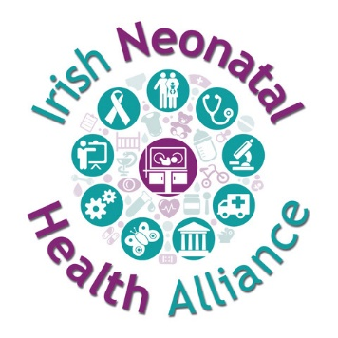

Irish Neonatal Health Alliance Submission to the Public Consultation on the introduction of a Statutory Sick Pay scheme

November 2020

Introduction
The Irish Neonatal Health Alliance (www.inha.ie) welcomes the Department of Enterprise, Trade and Employment public consultation on the introduction of a statutory right to paid sick leave for all employees, so that Ireland will be brought in line with other OECD countries.
We would like to take this opportunity to point out that not only is there no entitlement to statutory sick pay and no legal obligation on employers to pay workers during periods of illness, there is also no statutory entitlement in Ireland to bereavement leave and in particular there is no statutory entitlement to bereavement leave when a parent loses a child.
Parental Bereavement Leave (Amendment) Bill
We are very concerned that the Parental Bereavement Leave (Amendment) Bill (see https://www.oireachtas.ie/en/bills/bill/2019/23/) is not being progressed by the new Government.

We had previously been in contact with Deputy Anne Rabbitte in relation to concerns about the commitments in the proposed bill. The bill while very much welcomed was proposing that bereaved parents whose baby is over 24 weeks gestation or weighed more than 500g, as outlined as in the Stillbirth Registration Act of 1994, would be entitled to leave under the new Parental Bereavement Leave (Amendment) Bill.

We made representations to Deputy Rabbitte requesting that the proposed bill not use the cut off points of over 24 weeks gestation or over 500g. This is because parents of babies who are born below 24 weeks gestation and under 500g and who pass away should also be entitled to this leave.

Our asks
The Department of Enterprise, Trade and Employment needs to ensure that the Parental Bereavement Leave (Amendment) Bill continue to be progressed and be amended to include bereaved parents of babies who are born before 24 weeks gestation or who weigh under 500g.

If the Parental Bereavement Leave (Amendment) Bill is not progressed, all bereaved parents of children who die will not have any entitlement to paid leave from their employers after the passing of their child. Like, rights to sick pay, it will continue to be at the discretion of employers to offer bereaved parents leave, which cannot be depended upon. This is an opportune time to progress this bill alongside the proposed introduction of paid sick leave for all employees.

More information
If you would like to more information on in relation to this matter, please contact
Niamh Connolly-Coyne,
Board of Directors
Irish Neonatal Health Alliance

If you would like more information, please contact us:
Email: info@inha.ie
Phone: 085 1920 602

About the Irish Neonatal Health Alliance
The Irish Neonatal Health Alliance is a registered charity under Section 39 of the Charities Act 2009. RCN 20100100 CHY 21984. Website at: www.inha.ie

